Archiving and Compression

9.1 Introduction
In this chapter, we discuss how to manage archive files at the command line. File archiving is used when one or more files need to be transmitted or stored as efficiently as possible. There are two fundamental aspects which this chapter explores:
- Archiving: Combines multiple files into one, which eliminates the overhead in individual files and makes the files easier to transmit.
- Compression: Makes the files smaller by removing redundant information.

9.2 Compressing Files
Linux provides several tools to compress files; the most common is gzip.
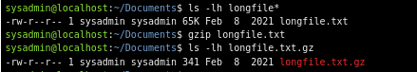

The file is compressed by invoking the gzip command with the name of the file as the only argument. After that command completes, the original file is gone, and a compressed version with a file extension of .gz is left in its place. The file size is now 341 bytes.
The gzip command will provide this information, by using the –l option, as shown here:

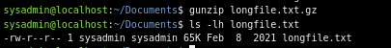
Compressed files can be restored to their original form using either the gunzip command or the gzip –d command. This process is called decompression. After gunzip does its work, the longfile.txt file is restored to its original size and file name.

There are other commands that operate virtually identically to gzip and gunzip. There is bzip2 and bunzip2, as well as xz and unxz.
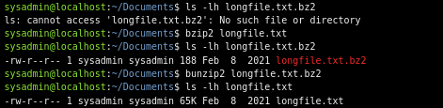

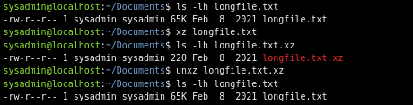

The gzip command uses the Lempel-Ziv data compression algorithm, while the bzip utilities use a different compression algorithm called Burrows-Wheeler block sorting, which can compress files smaller than gzip at the expense of more CPU time. These files can be recognized because they have a .bz or .bz2 extension instead of a .gz extension.
The xz and unxz tools are functionally similar to gzip and gunzip in that they use the Lempel-Ziv-Markov (LZMA) chain algorithm, which can result in lower decompression CPU times that are on par with gzip while providing the better compression ratios typically associated with the bzip2 tools. Files compressed with the xz command use the .xz extension.

9.3 Archiving Files
The traditional UNIX utility to archive files is called tar, which is a short form of TApe aRchive. It was used to stream many files to a tape for backups or file transfer. The tar command takes in several files and creates a single output file that can be split up again into the original files on the other end of the transmission.
The tar command has three modes that are helpful to become familiar with:
- Create: Make a new archive out of a series of files.
- Extract: Pull one or more files out of an archive.
- List: Show the contents of the archive without extracting.

9.3.1 Create Mode
tar -c [-f ARCHIVE] [OPTIONS] [FILE...]
Creating an archive with the tar command requires two named options:
Option | Function
-c | Create an archive.
-f ARCHIVE | Use archive file.  The argument ARCHIVE will be the name of the resulting archive file.

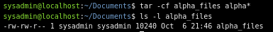
The final size of alpha_files.tar is 10240 bytes. Normally, tarball files are slightly larger than the combined input files due to the overhead information on recreating the original files. Tarballs can be compressed for easier transport, either by using gzip on the archive or by having tar do it with the -z option.
Option | Function
-z | Compress (or decompress) an archive using the gzip command.

The bzip2 compression can be used instead of gzip by substituting the -j option for the -z option and using .tar.bz2, .tbz, or .tbz2 as the file extension.
Option | Function
-j | Compress (or decompress) an archive using the bzip2 command.

9.3.2 List Mode
tar -t [-f ARCHIVE] [OPTIONS]
Given a tar archive, compressed or not, you can see what’s in it by using the -t option. The next example uses three options:
Option | Function
-t | List the files in an archive.
-j | Decompress with an bzip2 command.
-f ARCHIVE | Operate on the given archive.

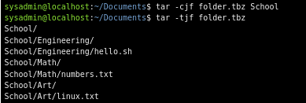

9.3.3 Extract Mode
tar -x [-f ARCHIVE] [OPTIONS]
you can extract the archive with the –x option once it’s copied into a different directory.
Option | Function
-x | Extract files from an archive.
-j | Decompress with the bzip2 command.
-f ARCHIVE | Operate on the given archive.
Add the –v flag and you will get a verbose output of the files processed, making it easier to keep track of what's happening:
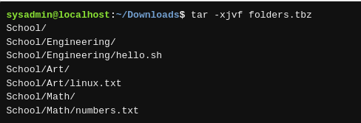

If you only want some files out of the archive, add their names to the end of the command, but by default, they must match the name in the archive exactly, or use a pattern.

9.4 ZIP Files
The de facto archiving utility in Microsoft is the ZIP file. ZIP is not as prevalent in Linux but is well supported by the zip and unzip commands. Albeit, with tar and gzip/gunzip the same commands and options can be used interchangeably to do the creation and extraction, but this is not the case with zip. The same option has different meanings for the two different commands.
The default mode of zip is to add files to an archive and compress it.
zip [OPTIONS] [zipfile [file…]]
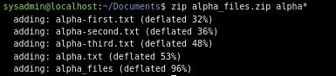

The output shows the files and the compression ratio.
The zip command will not recurse into subdirectories by default, which is different behavior than the tar command. That is, merely adding School will only add the empty directory and not the files under it. If you want tar like behavior, you must use the –r option to indicate recursion is to be used:
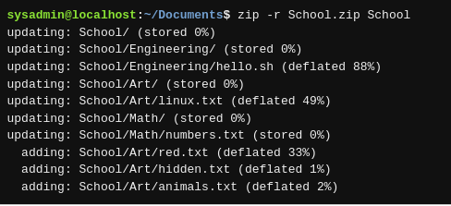

The –l list option of the unzip command lists files in .zip archives:
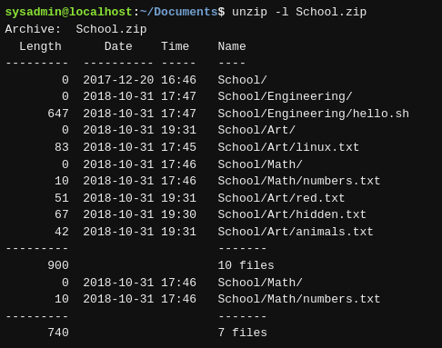

Extracting the files is just like creating the archive, as the default operation of the unzip command is to extract. It gives several options if unzipping files will overwrite existing ones:
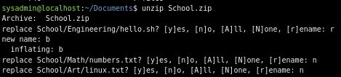

you can pass filenames on the command line. The examples below show three different attempts to extract a file.
First, just the name of the file is passed without the directory component. Like tar, the file is not matched.
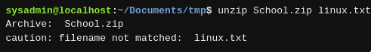

A second attempt passes the directory component along with the file name, which extracts just that file.
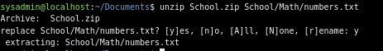

The third version uses a wildcard, which extracts the four files matching the pattern, just like tar.
